Hi Patricia,

I had the same problem, but I solved it. After I took the database from the folder of SingleResponsibilityPrincipleTests and put it to the folder SingleResponsibilityPrinciple.

Step 1

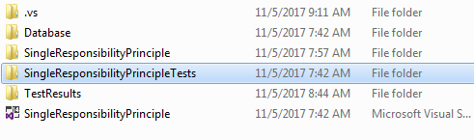

Step 2

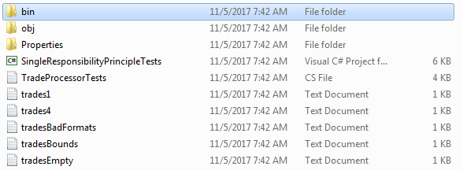

Step 3



Step 4

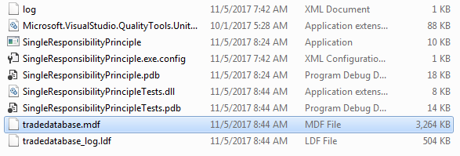

Step 5

